1. what is ternary search python?

* ternary search is a searching technique like binary search that is used to find the index or position of a particular value in collection of elements.
* Ternary search is used only on a sorted collection of elements.
* It is divided into 3 parts (where in binary search 2 parts) and then determines in which part the element exists
* Ternary search performs the search operation on the other 2/3 parts in every steps. this results in a worst-case time complexity of O(log3N), where N is the number of elements in the collection.

1. UML diagram

* UML stands for **U**nified **M**odeling **L**anguage. is a way of visualizing a software program using a collection of diagrams It’s a rich language to model software solutions, application structures, system behavior and business processes.
* There are two main categories; **structure diagrams** and **behavioral diagrams**
* **Structure diagrams** show the things in the modeled system. In a more technical term, they show different objects in a system. **Behavioral diagrams** show what should happen in a system. They describe how the objects interact with each other to create a functioning system.
* 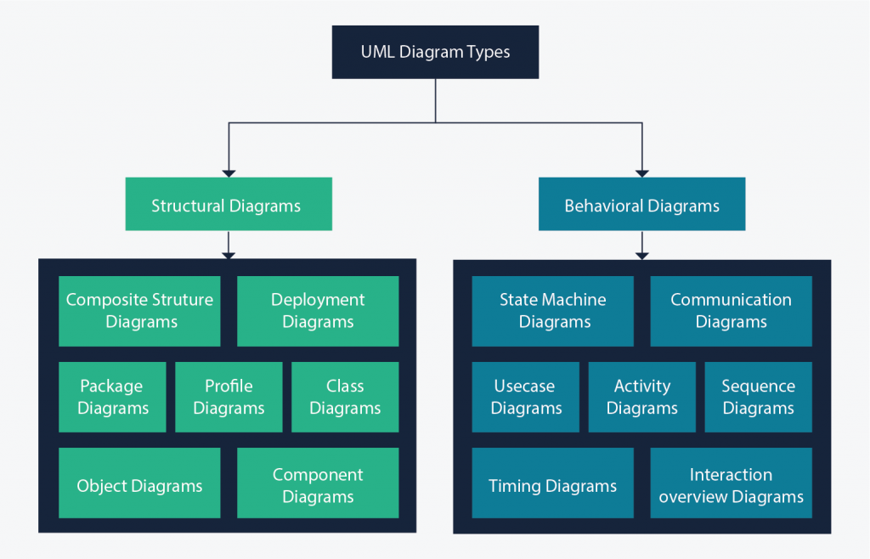

1. What is a DevOps tool?

* **DevOps Tool** is an application that helps automate the software development process. It mainly focuses on communication and collaboration between product management, software development, and operations professionals. DevOps tool also enables teams to automate most of the software development processes like build, conflict management, dependency management, deployment, etc. and helps reduce manual efforts.
* Here is the List of Best DevOps Tools:
* QuerySurge
* Basis Technologies
* Keysight Eggplant
* [Datadog](https://guru99.link/recommends-datadoghq-devops-tool)
* Solarwinds
* Jenkins
* Vagrant
* PagerDuty
* Prometheus

1. Agile vs DevOps: What's the difference?

1. Agile is defined by the Agile Manifesto, while there is no universally accepted definition of DevOps.  
2. DevOps defines a work culture, while Agile is a software development philosophy.  
3. Agile’s highest priority is continuous delivery, while for DevOps it’s continuous deployment.  
4. DevOps insists on the automation of all manual tasks, while Agile values “the amount of work not done.”  
5. DevOps practitioners embrace an Agile mindset, while Agile demands participants be self-organized and motivated.

Together, people with Agile mindsets who embrace a DevOps culture all share a common goal: the continuous delivery and deployment of software to the client.

When all participants embrace an Agile mindset, DevOps-based digital transformations can be successful

1. most common design patterns

* Software design patterns are reusable solutions that are not exactly the final product. It is a type of template for software design. They are not a code that can be directly converted into the software.
* Software design patterns are often the context to which a machine code is created. They can be repetitive, but never the same. It is not coded itself the can be reused.and instead an architecture to build new solutions.
* the 10 most used design patterns?

**Builder ( While Writing Unit Tests )  
Prototype ( Cloning )  
Adapter ( asList , toString )  
Chain Of Responsibility ( Logging )  
Singleton  
Factory ( Action Mapping )  
Proxy  
Observer ( Event Listener )  
MVC ( Web frameworks )  
Filter ( Criteria )**

1. Clean code Python

* Code should be elegant and pleasing to read.
* No duplication should be allowed.
* Code should be covered with tests.
* Every function should do one thing and do it well.
* Codebase should contain only code that is needed